**Lab Test 1**

**zzz is server1**

**b622 is server2**

**1.**

**Command**

sudo useradd -d /home/chow_zi_xuan -m chow_zi_xuan

sudo passwd chow_zi_xuan

scam605

scam605

sudo su chow_zi_xuan

echo $HOME

**Screenshot**

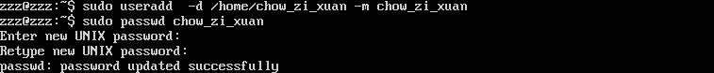

**2.**

**2.**

**Command**

**sudo usermod -aG sudo chow_zi_xuan**

**Screenshot**



**3.**

**File to be edited**

etc/network/interfaces

**Command to check / show the network interface available:**

sudo vim etc/network/interfaces

iface enp03s inet static

address 192.168.40.101

netmask 255.255.255.0

network 192.168.40.0

gateway 192.168.40.254

dns-nameservers 8.8.8.8

Save and Exit

:wq

**Screenshot**

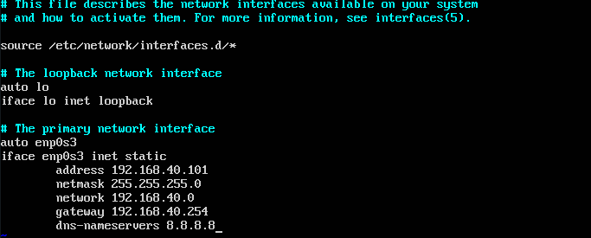

**Commands to make the new configuration of network interface takes effect**

systemctl restart networking.service

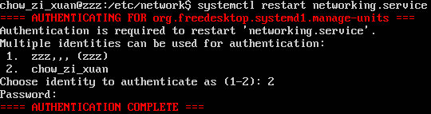

**4.**

**Command**

hostnamectl set-hostname server2

logout and login again

**Screenshot**

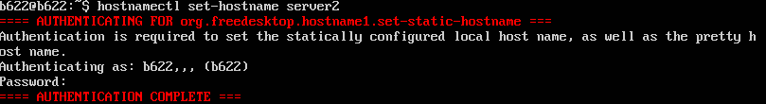

**5.**

**Command**

ping 192.168.40.101

**Screenshot**

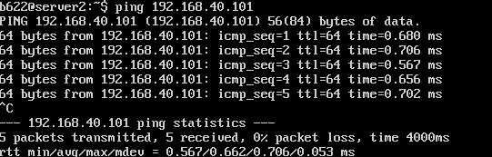

**6.**

**Command**

sudo service ssh status

**Screenshot**

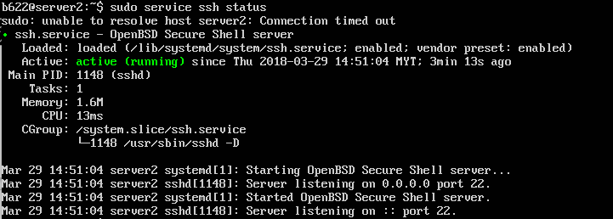

**7.**

**Command**

sudo service ssh status

**or**

vi /etc/ssh/sshd_config

**Screenshot**

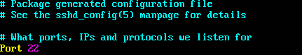

**8.**

**Command**

ssh-keygen

**Screenshot**

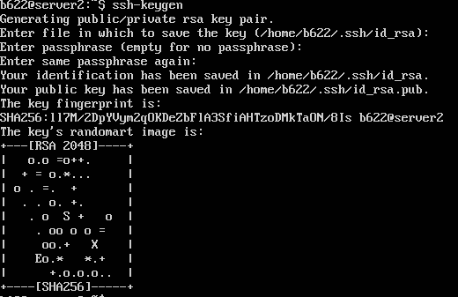

**9.**

**Command**

ssh-copy-id -i ~/.ssh/id_rsa.pub chow_zi_xuan@192.168.40.101

**Screenshot**

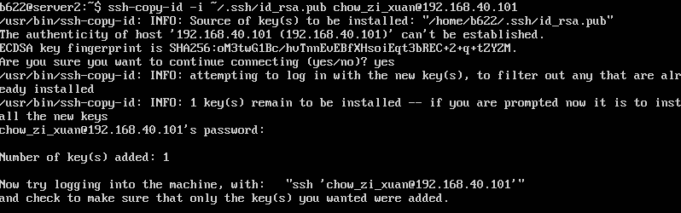

**10.**

**Command**

sudo vi /etc/ssh/sshd_config/

**Screenshot**

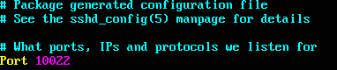

**11.**

**Command**

sudo service ssh restart

**Screenshot**

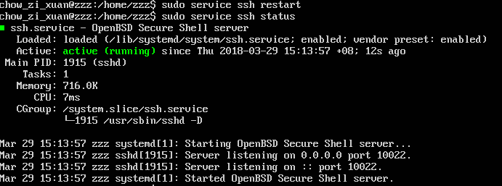

**12.**

**Command**

sudo pvcreate /*dev/*sdb

**Screenshot**



**13.**

**Command**

sudo vgcreate vg-db /dev/sdb

**Screenshot**



**14.**

**Command**

sudo lvcreate -n dbvol -l 100%FREE vg-db

**Screenshot**



**15.**

**Command**

sudo lvdisplay

**Screenshot**

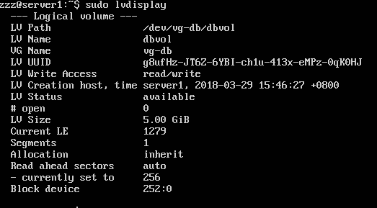

**16.**

**Command**

sudo mkfs.ext4 /dev/mapper/vg--db-dbvol

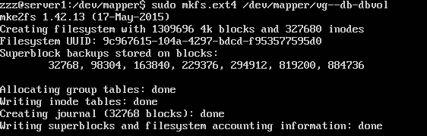**Screenshot**